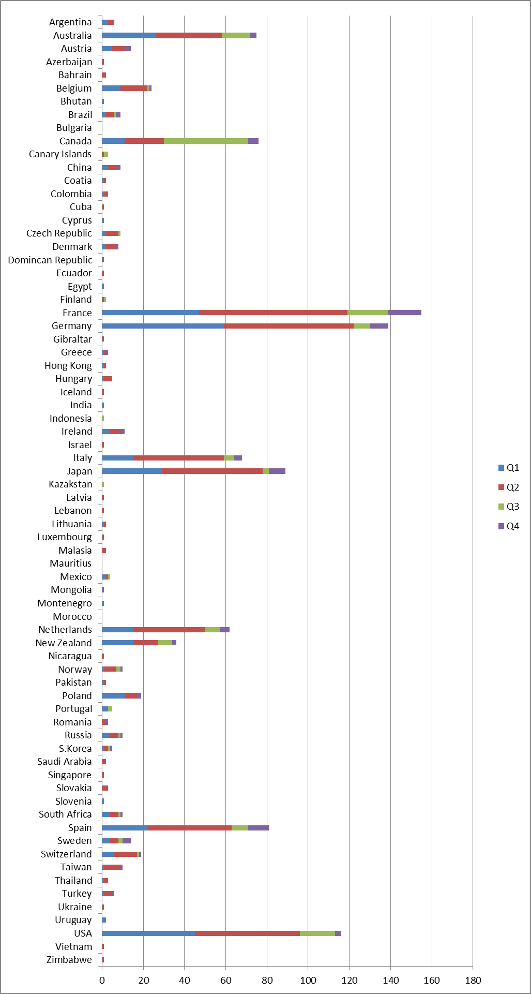

2018-2019 visitors to Lewes TIC broken down by country